
Sennheiser and Neumann Triumph at 40th Annual NAMM TEC Awards
Sennheiser HD 490 PRO and Neumann KK 104 U and KK 105 U Capsules Recognized for Excellence

Anaheim, CA, January X, 2025 — The Sennheiser Group is proud to announce that Sennheiser and Neumann.Berlin were both recognized for Outstanding Technical Achievement during the 40th Annual NAMM TEC Awards, held this past Thursday at the Hilton Pacific Ballroom in Anaheim California. The HD 490 PRO headphones have been presented with the prestigious TEC Award in the Headphone/Earpiece Technology category, while Neumann’s KK 104 U and KK 105 U microphone capsules received top honors in the Microphones – Sound Reinforcement category. This dual recognition highlights the ongoing commitment of both Sennheiser and Neumann to developing cutting-edge technology that advances the science of sound to meet the ever-evolving needs of the global audio community.
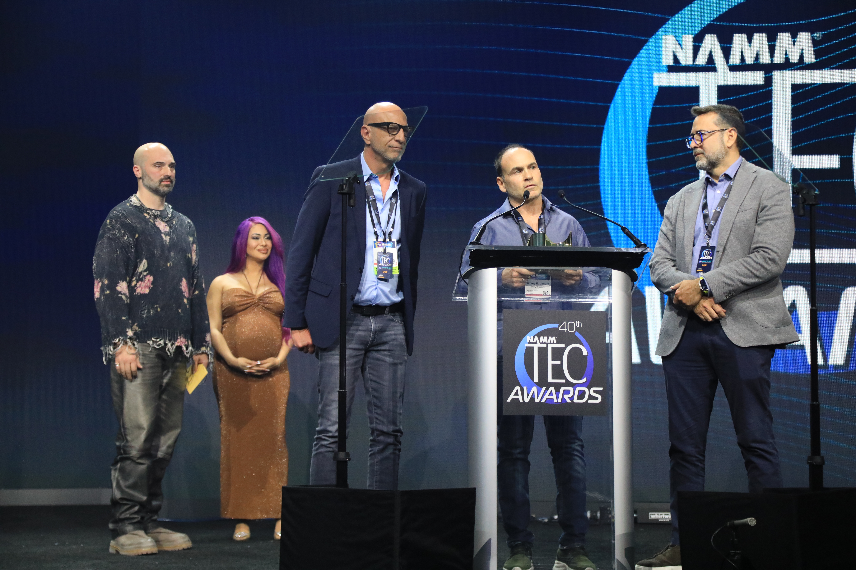
Sennheiser’s Barry Mitchell, Jimmy Landry and Hugo Caballero (left to right) accept the TEC Award for Headphone / Earpiece Technology.

The HD 490 PRO Headphones – A New Benchmark in Audio Quality
The TEC Foundation recognizes Sennheiser’s HD 490 PRO headphones for their exceptional sound performance, comfort, and versatility. The HD 490 PRO was designed with the professional audio industry in mind, delivering a balanced and transparent listening experience while maintaining durability for demanding studio environments.

“We are thrilled to receive this recognition for the HD 490 PRO headphones,” said Jimmy Landry, Category Market Manager, Sennheiser. “At Sennheiser, our goal is to create products that empower creators and professionals to achieve their best work. The HD 490 PRO exemplifies this ethos, offering uncompromising sound and a level of comfort that makes it the ideal choice for long listening sessions.”
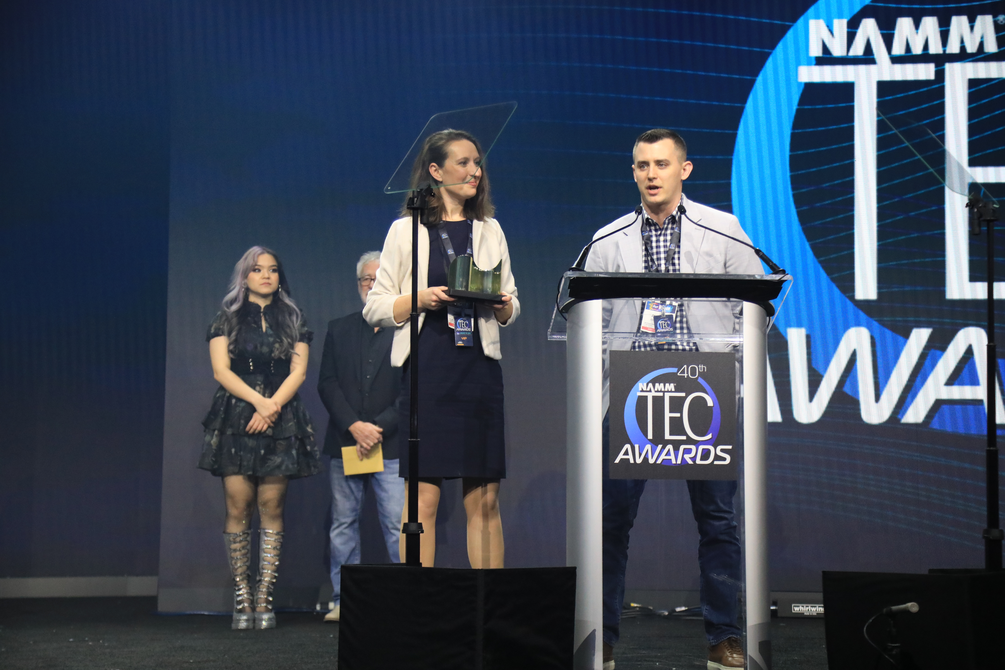
Neumann’s Yasmine Riechers and Jonathan Ruest accept the TEC Award for Microphones – Sound Reinforcement.

Neumann’s KK 104 U and KK 105 U Capsules – Premium Sound for Live Performance
Neumann’s KK 104 U and KK 105 U capsule heads were selected for the TEC Award in the Microphones – Sound Reinforcement category. These capsules for third-party wireless systems are designed for demanding live sound environments, delivering unmatched precision and clarity for live performances.

“We are incredibly proud that the KK 104 U and KK 105 U capsules have been recognized with this honor,” said Yasmine Riechers, CEO of Neumann. “Neumann has always been synonymous with excellence in studio recording. 25 years ago, we embarked on a journey to bring studio quality sound to the stage, developing our acclaimed KMS series and capsule heads for Sennheiser wireless systems. The KK 104 U and KK 105 U are the culmination of our dream to make Neumann sound available to everyone.”

A Legacy of Innovation and Excellence
Sennheiser and Neumann have a longstanding history of delivering industry-leading products for the music, broadcast, and audio engineering sectors. Since the TEC Foundation was established in 1990, Sennheiser and Neumann have together earned over 30 Outstanding Technical Achievement Awards and have several products in the TECnology Hall of Fame.
About the Sennheiser Group
Building the future of audio and creating unique sound experiences for our customers - this is the aspiration that unites the employees of the Sennheiser Group worldwide. The independent family-owned company Sennheiser was founded in 1945. Today, it is managed in the third generation by Dr. Andreas Sennheiser and Daniel Sennheiser and is one of the leading manufacturers in the field of professional audio technology. Within the Sennheiser Group are Georg Neumann GmbH (Berlin, Germany), manufacturer of studio-grade audio equipment; Dear Reality GmbH (Düsseldorf, Germany), known for its binaural, Ambisonics, and multichannel encoders with realistic room virtualization; and Merging Technologies SA (Puidoux, Switzerland), specialist in high-resolution digital audio recording systems.
sennheiser.com | neumann.com | dear-reality.com | merging.com

Local Press Contacts
Daniella Kohan Kirsten Spruch
daniella.kohan@sennheiser.com kirsten.spruch@sennheiser.com
+1 (860) 227-2235 + 1 (959) 239-7378

